***Youssef Saraya 320210002***

***Project***

**\*\*All the needed files are in the zip file (prediction excel sheet,code,etc…)\*\***

**Output data: kaggle kernels output youssefsaraya/youssefsaraya-nn-arabichandwriting -p /path/to/dest**

**Model Loss:**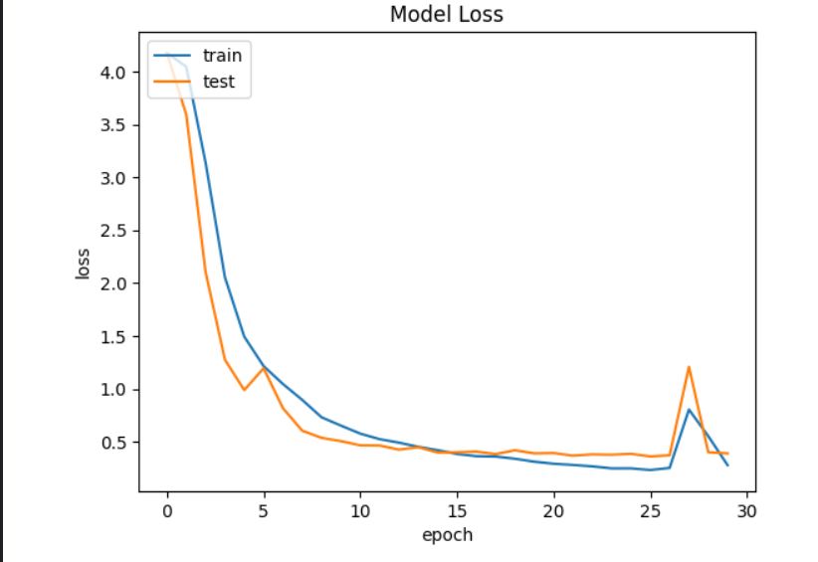

**Model Accuracy:**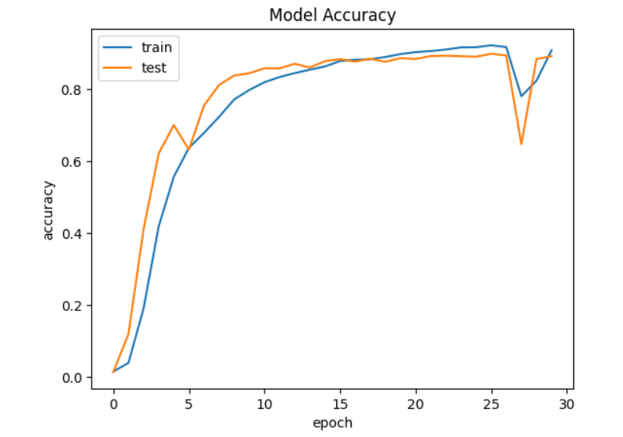

**Notebook Code:**

Found 42559 files belonging to 65 classes.

Using 34048 files for training.

Found 42559 files belonging to 65 classes.

Using 8511 files for validation.

Model: "sequential_1"

_________________________________________________________________

Layer (type) Output Shape Param #

=================================================================

rescaling_1 (Rescaling) (512, 160, 160, 1) 0

random_rotation_1 (RandomR (512, 160, 160, 1) 0

otation)

random_zoom_1 (RandomZoom) (512, 160, 160, 1) 0

conv2d_5 (Conv2D) (512, 160, 160, 32) 320

max_pooling2d_5 (MaxPoolin (512, 80, 80, 32) 0

g2D)

conv2d_6 (Conv2D) (512, 80, 80, 64) 18496

max_pooling2d_6 (MaxPoolin (512, 40, 40, 64) 0

g2D)

conv2d_7 (Conv2D) (512, 40, 40, 64) 36928

max_pooling2d_7 (MaxPoolin (512, 20, 20, 64) 0

g2D)

conv2d_8 (Conv2D) (512, 20, 20, 128) 73856

max_pooling2d_8 (MaxPoolin (512, 10, 10, 128) 0

g2D)

conv2d_9 (Conv2D) (512, 10, 10, 256) 295168

max_pooling2d_9 (MaxPoolin (512, 5, 5, 256) 0

g2D)

flatten_1 (Flatten) (512, 6400) 0

dense_2 (Dense) (512, 1024) 6554624

dropout_1 (Dropout) (512, 1024) 0

dense_3 (Dense) (512, 65) 66625

=================================================================

Total params: 7046017 (26.88 MB)

Trainable params: 7046017 (26.88 MB)

Non-trainable params: 0 (0.00 Byte)

_________________________________________________________________

Epoch 1/30

67/67 [==============================] - 23s 273ms/step - loss: 4.1758 - accuracy: 0.0150 - val_loss: 4.1746 - val_accuracy: 0.0137

Epoch 2/30

67/67 [==============================] - 19s 264ms/step - loss: 4.0436 - accuracy: 0.0389 - val_loss: 3.5923 - val_accuracy: 0.1194

Epoch 3/30

67/67 [==============================] - 20s 267ms/step - loss: 3.1378 - accuracy: 0.1902 - val_loss: 2.1041 - val_accuracy: 0.4101

Epoch 4/30

67/67 [==============================] - 20s 279ms/step - loss: 2.0544 - accuracy: 0.4181 - val_loss: 1.2753 - val_accuracy: 0.6206

Epoch 5/30

67/67 [==============================] - 19s 265ms/step - loss: 1.4929 - accuracy: 0.5563 - val_loss: 0.9880 - val_accuracy: 0.6999

Epoch 6/30

67/67 [==============================] - 20s 275ms/step - loss: 1.2149 - accuracy: 0.6364 - val_loss: 1.1943 - val_accuracy: 0.6314

Epoch 7/30

67/67 [==============================] - 20s 276ms/step - loss: 1.0456 - accuracy: 0.6781 - val_loss: 0.8172 - val_accuracy: 0.7541

Epoch 8/30

67/67 [==============================] - 21s 279ms/step - loss: 0.8952 - accuracy: 0.7227 - val_loss: 0.6040 - val_accuracy: 0.8113

Epoch 9/30

67/67 [==============================] - 20s 275ms/step - loss: 0.7309 - accuracy: 0.7711 - val_loss: 0.5366 - val_accuracy: 0.8375

Epoch 10/30

67/67 [==============================] - 21s 284ms/step - loss: 0.6524 - accuracy: 0.7974 - val_loss: 0.5056 - val_accuracy: 0.8437

Epoch 11/30

67/67 [==============================] - 19s 259ms/step - loss: 0.5767 - accuracy: 0.8189 - val_loss: 0.4659 - val_accuracy: 0.8575

Epoch 12/30

67/67 [==============================] - 20s 279ms/step - loss: 0.5243 - accuracy: 0.8331 - val_loss: 0.4643 - val_accuracy: 0.8572

Epoch 13/30

67/67 [==============================] - 20s 273ms/step - loss: 0.4915 - accuracy: 0.8441 - val_loss: 0.4252 - val_accuracy: 0.8699

Epoch 14/30

67/67 [==============================] - 19s 264ms/step - loss: 0.4519 - accuracy: 0.8535 - val_loss: 0.4482 - val_accuracy: 0.8597

Epoch 15/30

67/67 [==============================] - 20s 273ms/step - loss: 0.4206 - accuracy: 0.8625 - val_loss: 0.3979 - val_accuracy: 0.8772

Epoch 16/30

67/67 [==============================] - 19s 263ms/step - loss: 0.3841 - accuracy: 0.8775 - val_loss: 0.4004 - val_accuracy: 0.8830

Epoch 17/30

67/67 [==============================] - 19s 251ms/step - loss: 0.3637 - accuracy: 0.8812 - val_loss: 0.4068 - val_accuracy: 0.8759

Epoch 18/30

67/67 [==============================] - 19s 266ms/step - loss: 0.3601 - accuracy: 0.8826 - val_loss: 0.3834 - val_accuracy: 0.8838

Epoch 19/30

67/67 [==============================] - 21s 283ms/step - loss: 0.3394 - accuracy: 0.8889 - val_loss: 0.4194 - val_accuracy: 0.8756

Epoch 20/30

67/67 [==============================] - 20s 276ms/step - loss: 0.3113 - accuracy: 0.8969 - val_loss: 0.3901 - val_accuracy: 0.8856

Epoch 21/30

67/67 [==============================] - 20s 271ms/step - loss: 0.2921 - accuracy: 0.9024 - val_loss: 0.3930 - val_accuracy: 0.8834

Epoch 22/30

67/67 [==============================] - 20s 279ms/step - loss: 0.2805 - accuracy: 0.9054 - val_loss: 0.3685 - val_accuracy: 0.8914

Epoch 23/30

67/67 [==============================] - 20s 272ms/step - loss: 0.2674 - accuracy: 0.9096 - val_loss: 0.3805 - val_accuracy: 0.8926

Epoch 24/30

67/67 [==============================] - 19s 266ms/step - loss: 0.2482 - accuracy: 0.9156 - val_loss: 0.3774 - val_accuracy: 0.8911

Epoch 25/30

67/67 [==============================] - 20s 264ms/step - loss: 0.2484 - accuracy: 0.9159 - val_loss: 0.3857 - val_accuracy: 0.8897

Epoch 26/30

67/67 [==============================] - 19s 264ms/step - loss: 0.2328 - accuracy: 0.9216 - val_loss: 0.3612 - val_accuracy: 0.8978

Epoch 27/30

67/67 [==============================] - 19s 264ms/step - loss: 0.2524 - accuracy: 0.9165 - val_loss: 0.3717 - val_accuracy: 0.8932

Epoch 28/30

67/67 [==============================] - 20s 271ms/step - loss: 0.8041 - accuracy: 0.7798 - val_loss: 1.2082 - val_accuracy: 0.6467

Epoch 29/30

67/67 [==============================] - 19s 266ms/step - loss: 0.5524 - accuracy: 0.8231 - val_loss: 0.4003 - val_accuracy: 0.8832

Epoch 30/30

67/67 [==============================] - 20s 272ms/step - loss: 0.2781 - accuracy: 0.9079 - val_loss: 0.3897 - val_accuracy: 0.8910

Found 10640 files belonging to 1 classes.

21/21 [==============================] - 5s 233ms/step

**Logs:**

